
e
CGI Inc. Project Lessons Learned Report



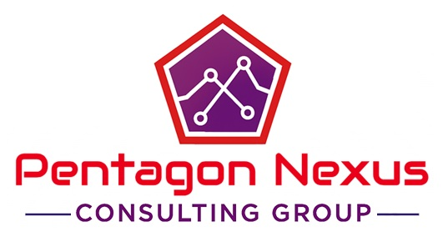
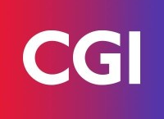

Simon Sarkodie 8960492
Mohana Dutta 8990773
Ya-Jwu Jang 9015996
Meet Rajendrakumar Patel 9019384
Vasukrishna Ashokkumar Bhalodia 9018135
Capstone Project
December 20, 2025
BLAIR MOCH | INFO8687 | SECTION 1
Table of Contents
1. Identify a major strength and a weakness in your inter-team communication and document how each of these impacted your team’s ability to function effectively. 3
2. What did you learn about team leadership and team membership? 3
3. What was the job of the client in your project? (Include ALL that your client was responsible for throughout the project.) 3
4. How were conflicts/challenges in your team resolved? Please provide examples and include how your team resolved the situation to avoid a team breakdown. 4
5. What did your team learn about the project process through each stage of this project? 4
6. What worked well for your team that supported the completion of the various parts? 4
7. Reflect on your team’s delivery – what would you do differently now that would improve the quality of your solution? 5

Identify a major strength and a weakness in your inter-team communication and document how each of these impacted your team’s ability to function effectively.
A major strength of our inter-team communication was our ability to collaborate effectively through direct, fast, and respectful communication. We consistently used scheduled check-ins, WhatsApp updates, and shared files. There was consistent access to information across team members and clarity of expected actions, who was responsible and the timing of actions leading to unblocked flow of work. There was mutual respect across to hear every voice and the value of contribution which was the basis of collaboration to enhance the output.
A key weakness was that response delays sometimes occurred because some of the members had part-time jobs and different schedules. This made it difficult to arrange meeting times and occasionally slowed group decision-making. And also sometimes, too many discussion messages confuse priorities. These challenges taught us the importance of organizing communication more clearly, setting priority markers, and finding better ways to coordinate availability.

What did you learn about team leadership and team membership?
Team Member
As a team member our biggest learning was to take a step forward and accountable ourselves for the responsibilities to complete the assignments. We learned as a team member that active participation in any discussion will show team spirit. We learned about opinionative approach, listening norms and responsibilities to complete the assigned task. We learned team collaboration plays a vital role in projects.
Team Leader
As team leader we learned how to change our leadership style according to the circumstances which should not be linear. We learned to support other members and appreciate their work to encourage them. We learned about assigned tasks precisely providing a clear direction to the team.

What was the job of the client in your project? (Include ALL that your client was responsible for throughout the project.)
In our project, the client and also our project sponsor, Blair Moore, (CGI) was responsible for providing the business context behind the challenge we were addressing. She acted as key stakeholders and gave feedback on our ideas, reviewed our proposed digital health solution, and validated assumptions throughout the stages of the project. They clarified requirements, approved key decisions, and ensured our work aligned with CGI’s business needs throughout the project. They ensured our work aligned with BA standards and project requirements. Overall, the client played an advisory role, helping us make sure that our work stayed relevant and realistic.

How were conflicts/challenges in your team resolved? Please provide examples and include how your team resolved the situation to avoid a team breakdown.
We had varying understanding of assignment requirements. For example, we were not sure whether we ought to have done a SWOT analysis of CGI or our consulting team. We solved this by contacting our professor for confirmation. Secondly, we also had differing opinions about the number of solutions options to offer. To cite an example, two of the members desired one solution option and the others demanded three so as to make a more credible comparison. We dealt with this by taking time to do personal research, re-convening, and jointly agreeing on the number of options depending on the evidence and the scope of the project. Lastly, we were in a dilemma on the B2B2C model when choosing the company. For instance, the members of the team had difficulties grasping the role of a company such as CGI within the B2B2C model. We resolved this by taking a detailed explanation session where we disaggregated the business model till no one had a question.

What did your team learn about the project process through each stage of this project?
We learned that each project stage builds on the previous one and that skipping a stage to the next could create bigger problems later. During the discovery stage, we saw how crucial it is to truly understand the client’s context: CGI’s dependence on government contracts and desire for a scalable B2B2C digital health solution, before jumping into solution design. In the analysis and design stages, we realized the value of modelling different scenarios for revenue growth and risk, which helped us create a more realistic and defensible roadmap for the digital health companion app. The development of deliverables (such as the storyboard, fishbone diagram, and ROI) showed us how important it is to keep documentation consistent and aligned with the core problem statement. lastly, in the final and poster presentation stages, we learned that how we communicate the solution (storytelling, visuals, clarity) is just as important as the solution itself in convincing stakeholders.

What worked well for your team that supported the completion of the various parts?
Dividing work according to the strengths of every member of the group helped us to work effectively as well as minimizing confusion during the project. The constant updates and files sharing on WhatsApp made us all aware and made sure we always had the updated documents. Check-ins, even informal ones, were very regular, which allowed us to keep track and respond fast to the questions or explain the requirements. The advantages of the sharing of the parts that were completed early on were that the other parts of the team could correct their own parts to make a more flowing and cohesive final submission. A high level of commitment and support made sure that each member gave their best and quality work was achieved and the overall process was not that stressful.

Reflect on your team’s delivery – what would you do differently now that would improve the quality of your solution?
We would also enhance the early teamwork in order to ensure that all people comprehend project requirements at an earlier stage. We would talk to the client more often in order to confirm assumptions before making major decisions. To make it less confusing and enhance coordination, we would keep a well-organized record of meeting notes and decisions. We would initiate in-house audits sooner, enabling us to have more time to refine the analysis and enhance clarity. To make the end solution more evidence-based and refined, we would improve our competitive research and journey maps.

Conestoga College
Information Technology Business Analysis

Capstone Project
Fall 2025, ITBA

